Update Instructions for ASC Gen 4

Contents
General Information 2
Controller Update with Update Package 3
Update InScript Firmware 6
Update Controller FPGA 8
Update Scanhead FPGA 10

General Information

We recommend to update with complete Controller Update Package, which is described in the chapter “Controller Update with Update Package”.
It is also possible to update the parts of the system – like InScript Firmware, Controller FPGA and Scanhead FPGA.

Controller Update with Update Package
- Download the correct file from the download area.
Note: Which kind of ASC you have please find in the ASC Gen4 manual in chapter 3.
- ASC1 Update Package.zip
This is the update package for ASC1
- ASC2_No_WFI_Update_Package.zip
This is the update package for ASC2 without WFI
- ASC2_WFI_Update_Package.zip
This is the update package for ASC2 with WFI
- ASC6_WFI_Update_Package.zip
This is the update package for ASC6 with WFI
- Unpack the controller specific ZIP-File. It contains
- InScript 3.1.0
- Firmware 3.1.0
- Buildroot
- FPGA-Update (In this example it is the ASC1 Update Package)
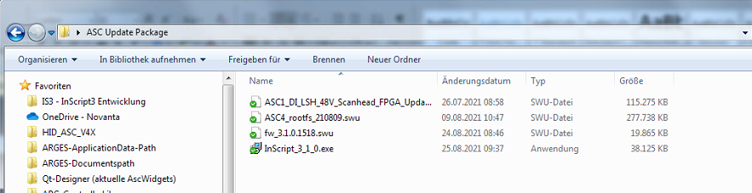
- Install InScript_3_1_0.exe on your PC
- Start InScript 3.1.0
- In InScript add the Controller you want to update by clicking the 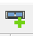 symbol and enter the IP address of the controller
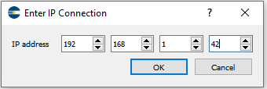
- Right click on the controller in the Navigator in InScript and choose Controllerservices…
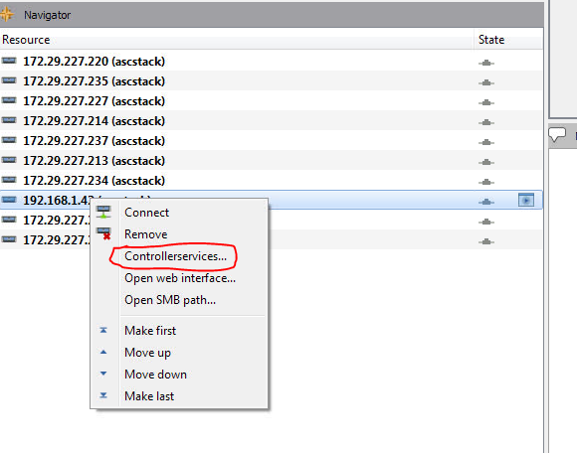
- After the dialog has opened choose the tab Update
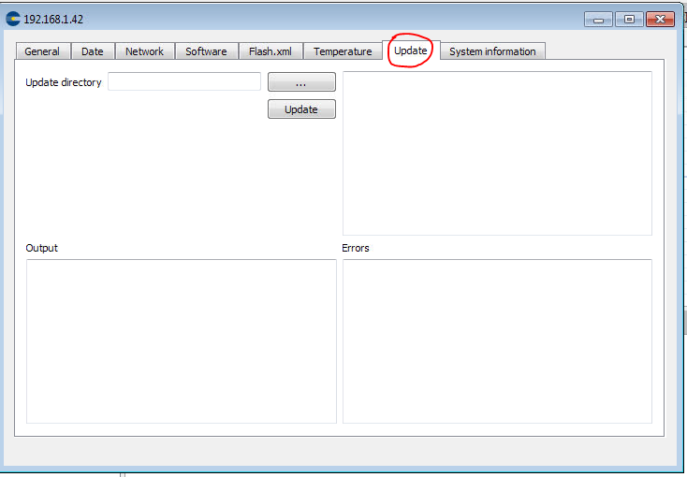
- Click the …-button and choose the directory, where all your update files are located (the directory, the ZIP-File was extracted to)
- After choosing the directory, click the Update-button.
- The procedure needs about 20 to 30 minutes to finish. After the procedure finishes you can save the protocol.
- Please notice, that it is normal, that messages appear in the “Errors”-section
- Please power-cycle the ASC to apply the changes

Update InScript Firmware
- Download the correct firmware-file from the Download area “Firmwarepackages” (fw-3.1.0.1518.swu, as of today 22.09.2021)
- Start InScript 3.1.0
- In InScript add the Controller you want to update by clicking the symbol and enter the IP address of the controller
- Right click on the controller in the Navigator in InScript and choose Controllerservices…
- Switch to the tab Software and click the …-button and choose the directory, where your firmwarefile is located
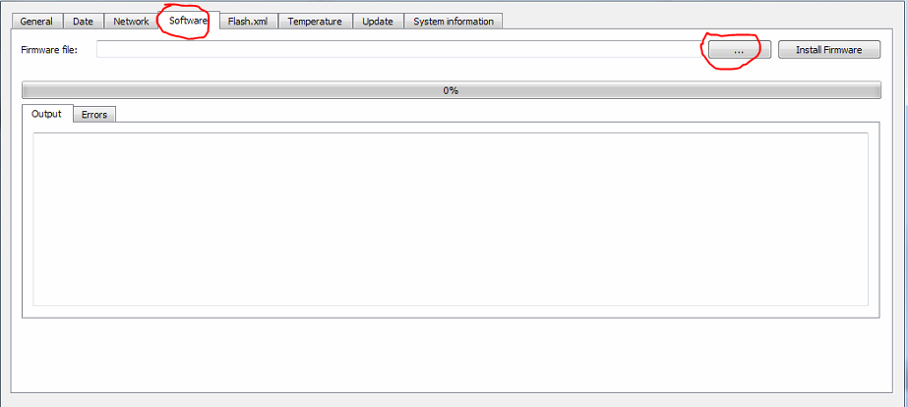
- After choosing the directory, click the Install Firmware-button.
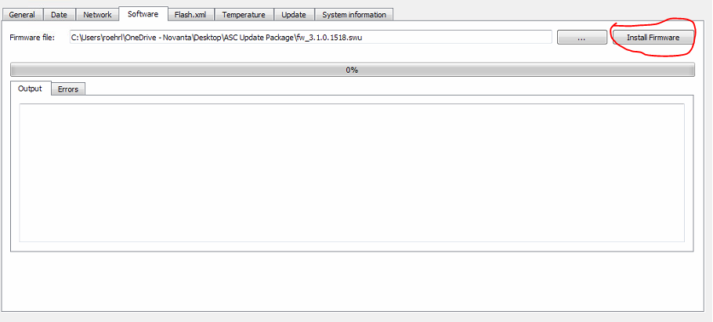
- The procedure needs about a few minutes to finish.
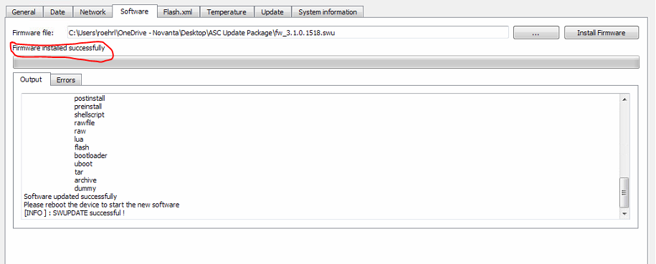
- Please notice, that it is normal, that messages, that look like errors appear in the output field. As long as ‘SWUPDATE successful’ message will appear everything is fine.

Update Controller FPGA
- Download the correct file from the download area.
Note: Which kind of ASC you have please find in the ASC Gen4 manual in chapter 3.
- ASC1_DI_LSH_48V_Scanhead_FPGA_Update
This is the update package for ASC1
- ASC2_DI_LSH_48V_Scanhead_FPGA_Update
This is the update package for ASC2 without WFI
- ASC2_DI_LSH_OCT_48V_Scanhead_FPGA_Update
This is the update package for ASC2 with WFI
- ASC6_Microlution_48V_Scanhead_FPGA_Update
This is the update package for ASC6 with WFI
- Start InScript 3.1.0
- In InScript add the Controller you want to update by clicking the symbol and enter the IP address of the controller
- Right click on the controller in the Navigator in InScript and choose Controllerservices…
- Switch to the tab Software and click the …-button and choose the directory, where your Scanhead FPGA file is located
- After choosing the directory, click the Install Firmware-button.
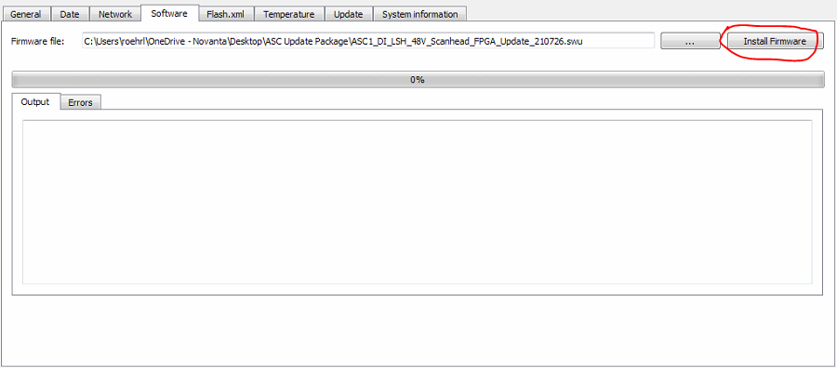
- The procedure needs a few minutes to finish.
- Please notice, that it is normal, that messages, that look like errors appear in the output field. As long as ‘SWUPDATE successful’ message will appear everything is fine.
- Please power-cycle the ASC to apply the changes

Update Scanhead FPGA
- Download the update package for your scanhead from the download area “Scanhead FPGA” (ARG_DG_BB_Update21012705.swu)
- Start InScript 3.1.0
- In InScript add the Controller you want to update by clicking the symbol and enter the IP address of the controller
- Right click on the controller in the Navigator in InScript and choose Controllerservices…
- Switch to the tab Software and click the …-button and choose the directory, where your Scanhead FPGA file is located
- After choosing the directory, click the Install Firmware-button.
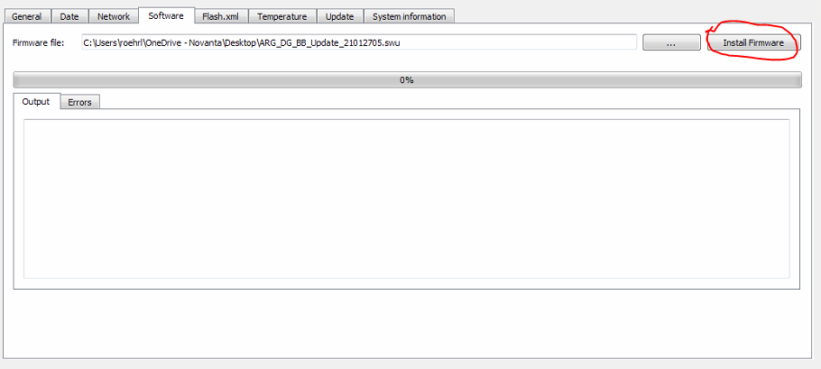
- The procedure needs a few minutes to finish.
- Please notice, that it is normal, that messages, that look like errors appear in the output field. As long as ‘SWUPDATE successful’ message will appear everything is fine.
- Please power-cycle the ASC to apply the changes

